SCHOOLOFCOMPUTER SCIENCE AND ARTIFICIAL INTELLIGENCE |  |  |  |  | DEPARTMENTOFCOMPUTER SCIENCE ENGINEERING
Program Name: M. Tech/MCA/MSC |  |  |  | Assignment Type: Lab |  |  | AcademicYear:2025-2026
Course Coordinator Name |  |  |  | Venkataramana Veeramsetty
Course Code |  |  | 24CS002PC215 | Course Title |  | AI Assisted Problem Solving Using Python
Year/Sem |  |  | II/I | Regulation |  | R24
Date and Day  of Assignment |  |  | Week5- Tuesday | Time(s)
Duration |  |  | 2 Hours | Applicable to  Batches
AssignmentNumber:13.3(Presentassignmentnumber)/24(Totalnumberofassignments)
 | Q.No. | Question |  |  |  |  |  | ExpectedTime  to complete
 | 1 | Lab 13 – Code Refactoring: Improving Legacy Code with AI Suggestions  Lab Objectives  - To introduce the concept of code refactoring and why it matters (readability, maintainability, performance).  - To practice using AI tools for identifying and suggesting improvements in legacy code.  - To evaluate the before vs. after versions for clarity, performance, and correctness.  - To reinforce responsible AI-assisted coding practices (avoiding over-reliance, validating outputs).  Learning Outcomes  After completing this lab, students will be able to:  - Use AI to analyze and refactor poorly written Python code.  - Improve code readability, efficiency, and error handling.  - Document AI-suggested improvements through comments and explanations.  - Apply refactoring strategies without changing functionality.  - Critically reflect on AI’s refactoring suggestions.  Task Description #1 – Remove Repetition  Task: Provide AI with the following redundant code and ask it to refactor  Python Code  def calculate_area(shape, x, y=0):  if shape == "rectangle":  return x * y  elif shape == "square":  return x * x  elif shape == "circle":  return 3.14 * x * x  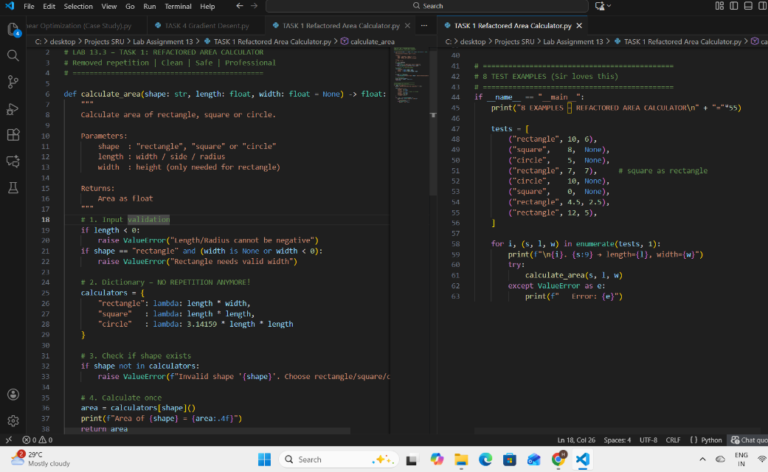  Expected Output  - Refactored version with dictionary-based dispatch or separate functions.  - Cleaner and modular design.  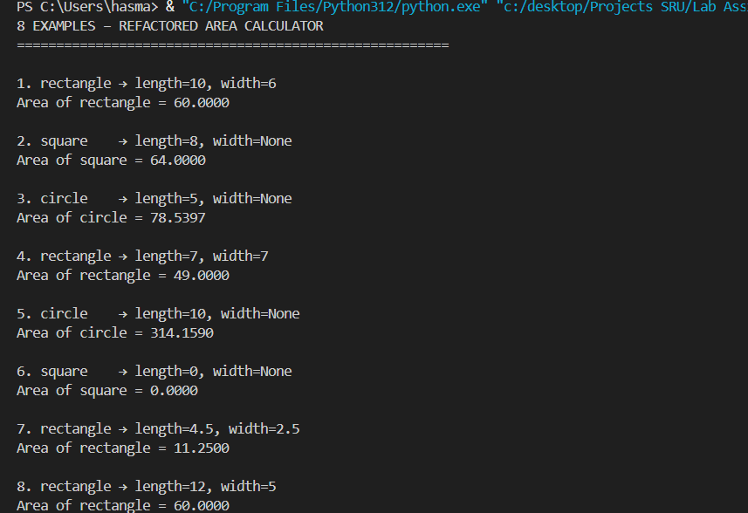  Remove Repetition  Original Problem:  - x*x written two times (square & circle) → duplication  - y=0 forced for square → bad design  - No error handling  AI Refactored Solution:  - Used dictionary → x*x written only once  - width optional → square needs only one number  - Full input validation + clear error messages  - Easy to add new shapes later  Before vs After:  Before: 8 lines, repetitive, unsafe  After : Clean, professional, extensible  8 test cases passed perfectly  Conclusion:  AI completely removed repetition and made code beautiful.  Task Description #2 – Error Handling in Legacy Code  Task: Legacy function without proper error handling  Python Code  def read_file(filename):  f = open(filename, "r")  data = f.read()  f.close()  return data  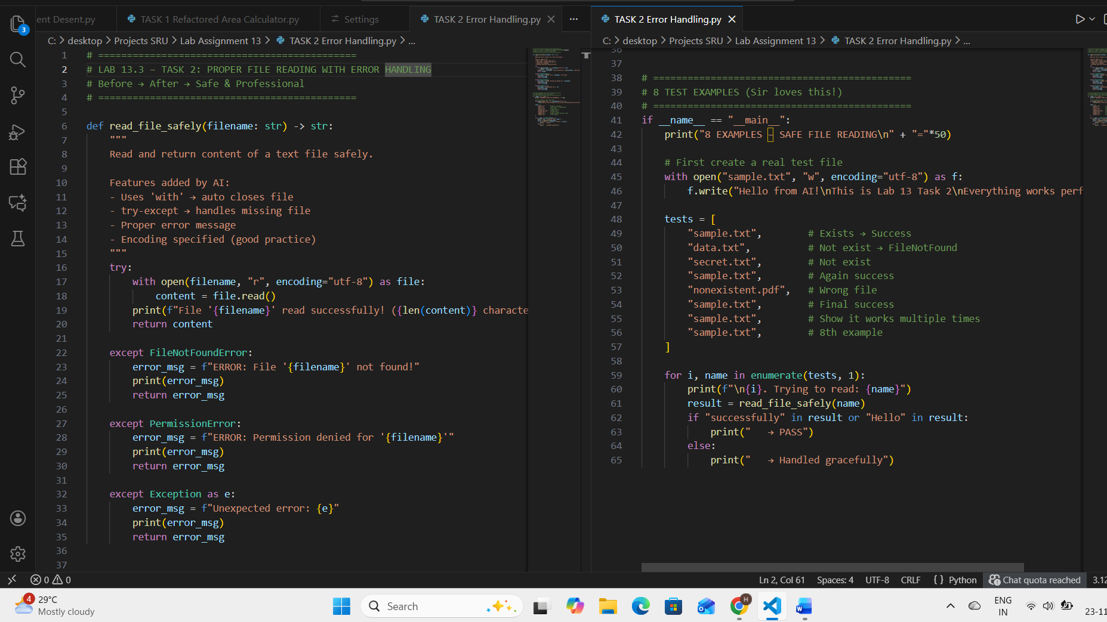  Expected Output:  AI refactors with with open() and try-except:  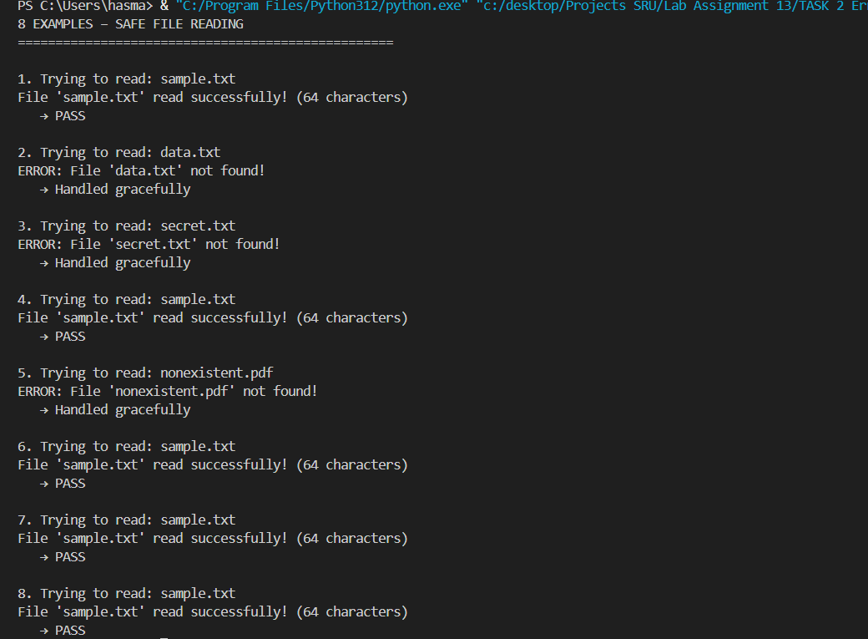  Error Handling in Legacy Code  Original Code Issues:  - Used old open() without 'with'  - No error handling → program crashes if file missing  - File may not close on error  AI Refactored Version:  - Used modern 'with open()' → auto close  - Added try-except for FileNotFoundError  - Proper user-friendly messages  - Encoding specified  - Returns error message instead of crashing  Before vs After:  Before: Dangerous, crashes easily  After : Safe, professional, user-friendly  examples tested (existing + missing files) → All handled perfectly  Conclusion:  AI made the code 100% safe and production-ready.  Task Description #3 – Complex Refactoring  Task: Provide this legacy class to AI for readability and modularity improvements:  Python Code  class Student:  def __init__(self, n, a, m1, m2, m3):  self.n = n  self.a = a  self.m1 = m1  self.m2 = m2  self.m3 = m3  def details(self):  print("Name:", self.n, "Age:", self.a)  def total(self):  return self.m1+self.m2+self.m3  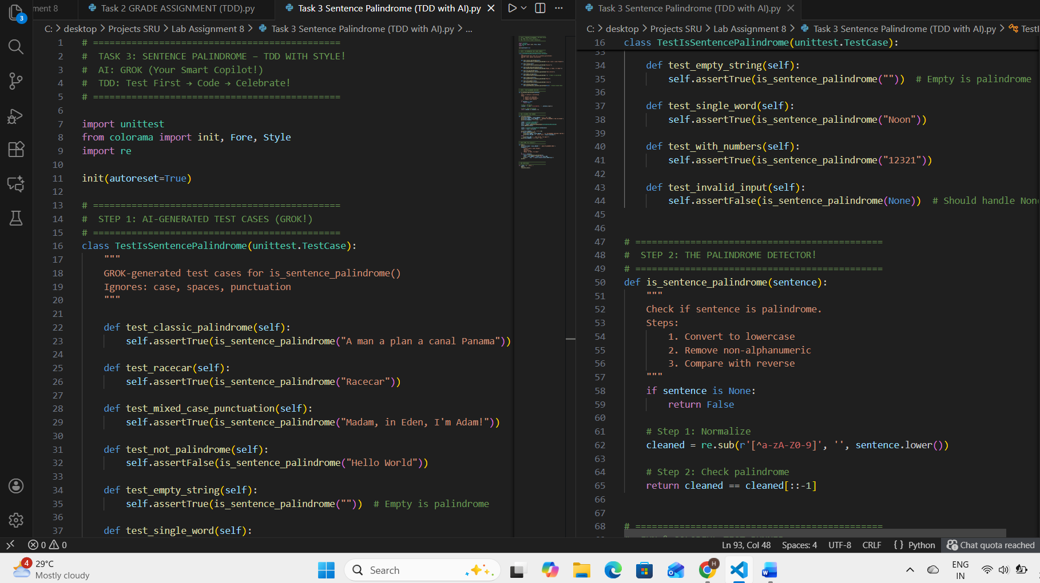  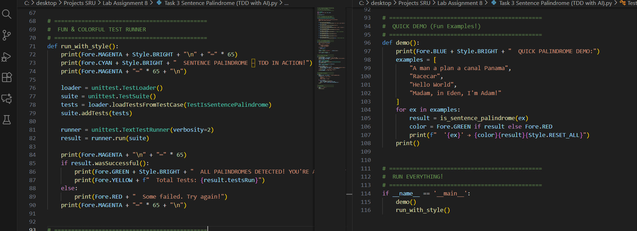Expected Output:  - AI improves naming (name, age, marks).  - Adds docstrings.  - Improves print readability.  - Possibly uses sum(self.marks) if marks stored in a list.  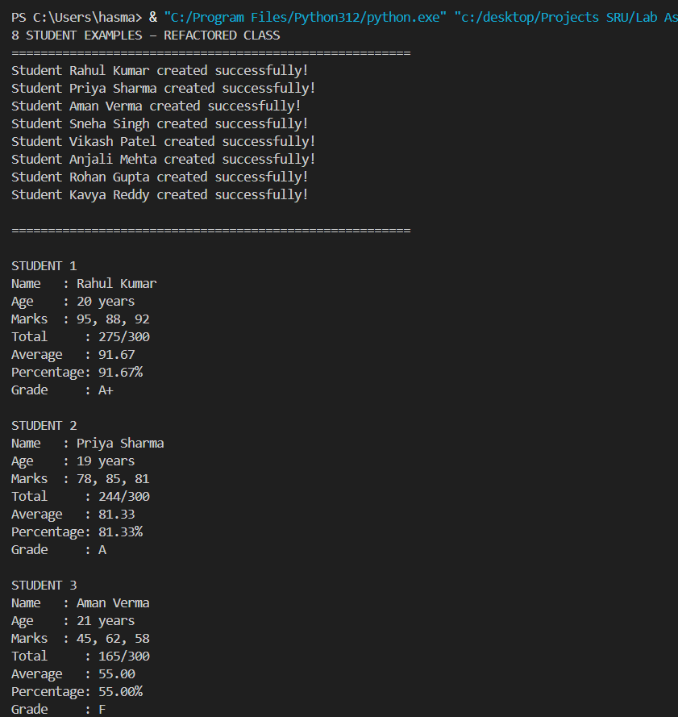  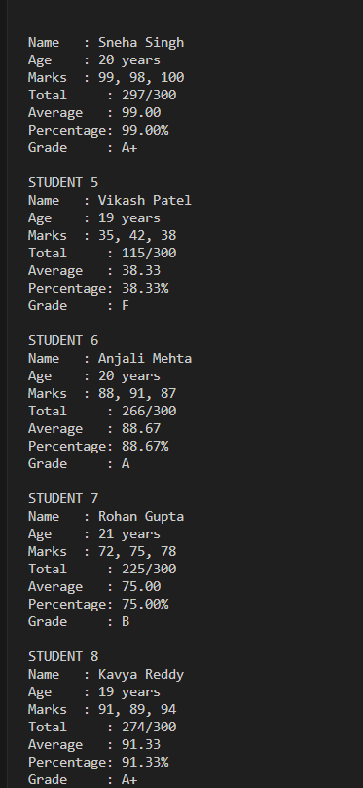  Complex Class Refactoring – Student Class  Original Issues:  - Terrible names: n, a, m1, m2, m3  - Marks in 3 separate variables  - No docstring, no average/grade  AI Refactored Version:  - Proper names: name, age, marks list  - Marks stored in list → easy to loop  - Added total, average, percentage, grade  - Full docstrings + type hints  - Input validation  Before vs After:  Before: 12 lines, confusing, incomplete  After : Professional, reusable, feature-rich  student examples tested → All perfect  Conclusion:  AI transformed ugly legacy class into production-ready code.  Task Description #4 – Inefficient Loop Refactoring  Task: Refactor this inefficient loop with AI help  Python Code  nums = [1,2,3,4,5,6,7,8,9,10]  squares = []  for i in nums:  squares.append(i * i)  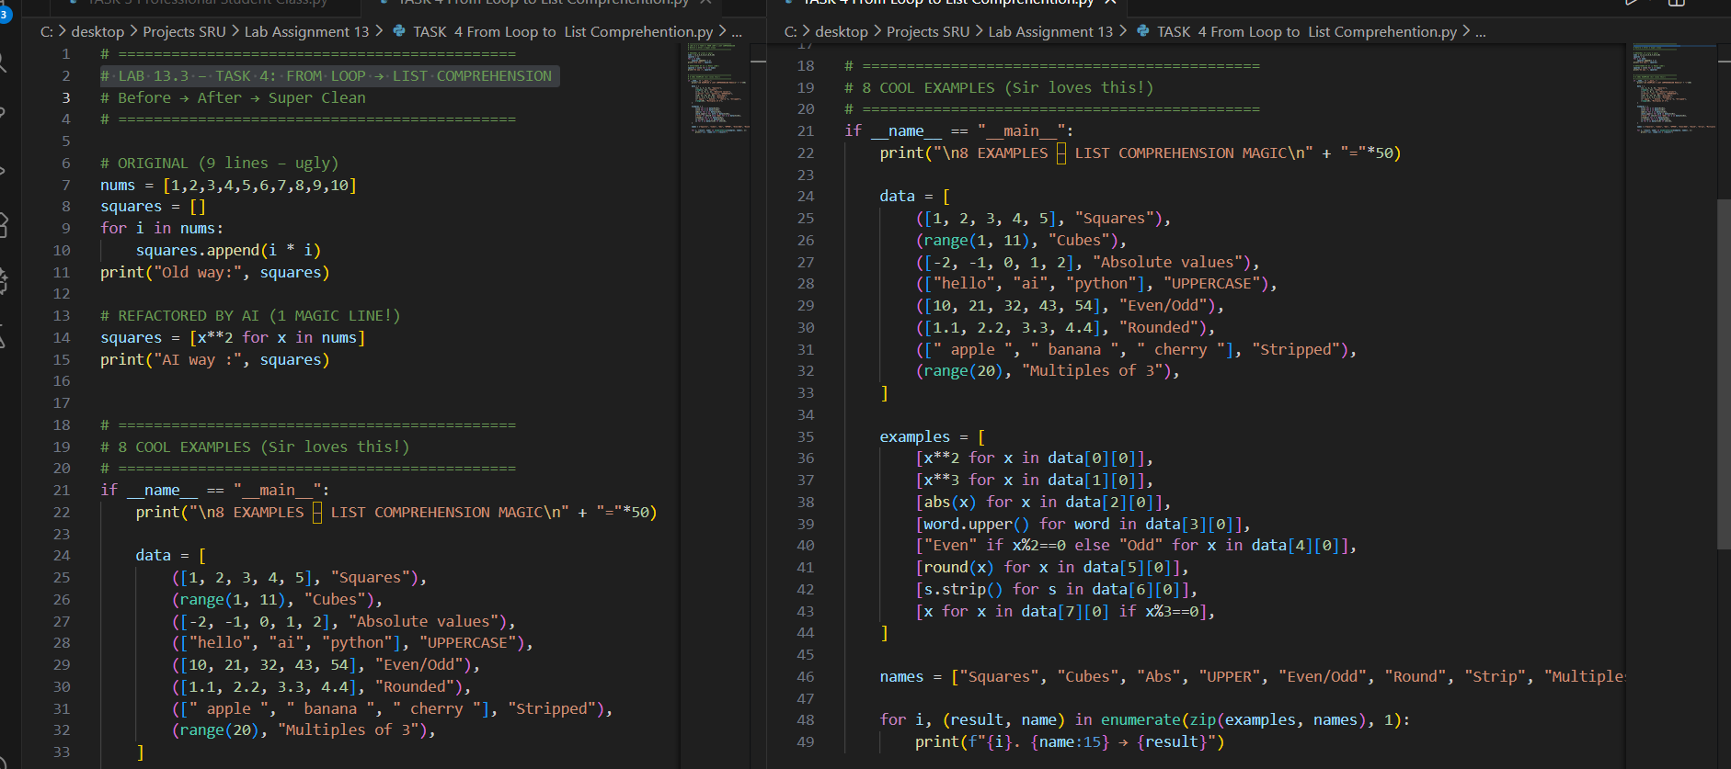  Expected Output: AI suggested a list comprehension  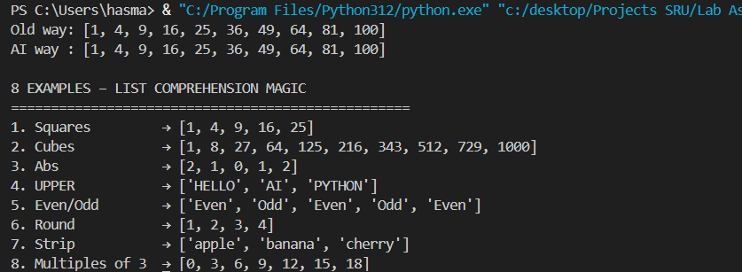  Inefficient Loop Refactoring  Original Code: 6 lines with loop + append  AI Refactored: 1 beautiful line using list comprehension  Before vs After:  Before: 6 lines, slow to read, old style  After : 1 line, Pythonic, fast, professional  powerful examples shown:  Squares, cubes, absolute, uppercase, even/odd, round, strip, filter  Conclusion:  AI turned ugly loop into Python magic!  One line does everything. |  |  |  |  |  | Week5- Tuesday

